 



Database Programming with SQL 15-3: Managing Views

Practice Activities

# Objectives

* Create and execute a query that removes a view
* Create and execute a query using an inline view
* Create and execute a top-n-analysis query

# Vocabulary

Identify the vocabulary word for each definition below.

|  |  |
| --- | --- |
| **TOP-N Analysis** | Asks for the N largest or smallest values in a column |
| **DROP** VIEW view_name | Removes a view |
| **INLINE VIEW** | Subquery with an alias that can be used within a SQL statement |

# Try It / Solve It

1. Create a view from the copy_d_songs table called view_copy_d_songs that includes only the title and artist. Execute a SELECT * statement to verify that the view exists.

CREATE OR REPLACE VIEW view_copy_d_songs AS

SELECT title, artist

FROM copy_d_songs;

SELECT * FROM view_copy_d_songs;

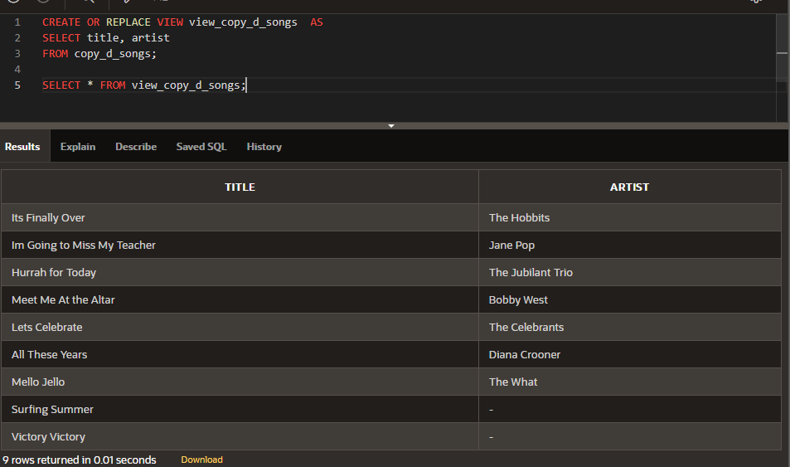

1. Issue a DROP view_copy_d_songs. Execute a SELECT * statement to verify that the view has been deleted.

DROP VIEW view_copy_d_songs;

SELECT * FROM view_copy_d_songs;

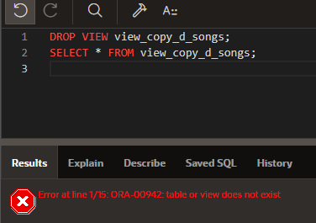

1. Create a query that selects the last name and salary from the Oracle database. Rank the salaries from highest to lowest for the top three employees.

SELECT * FROM

(SELECT last_name, salary FROM employees ORDER BY salary DESC)

WHERE ROWNUM <= 3;

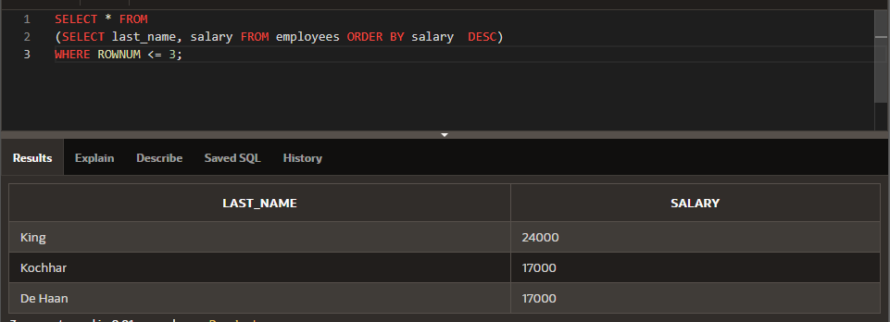

1. Construct an inline view from the Oracle database that lists the last name, salary, department ID, and maximum salary for each department. Hint: One query will need to calculate maximum salary by department ID.

SELECT empm.last_name, empm.salary, dptmx.department_id

FROM

(SELECT dpt.department_id, MAX(NVL(emp.salary,0)) max_dpt_sal

FROM departments dpt LEFT OUTER JOIN employees emp ON dpt.department_id = emp.department_id

GROUP BY dpt.department_id) dptmx LEFT OUTER JOIN employees empm ON dptmx.department_id = empm.department_id

WHERE NVL(empm.salary,0) = dptmx.max_dpt_sal;

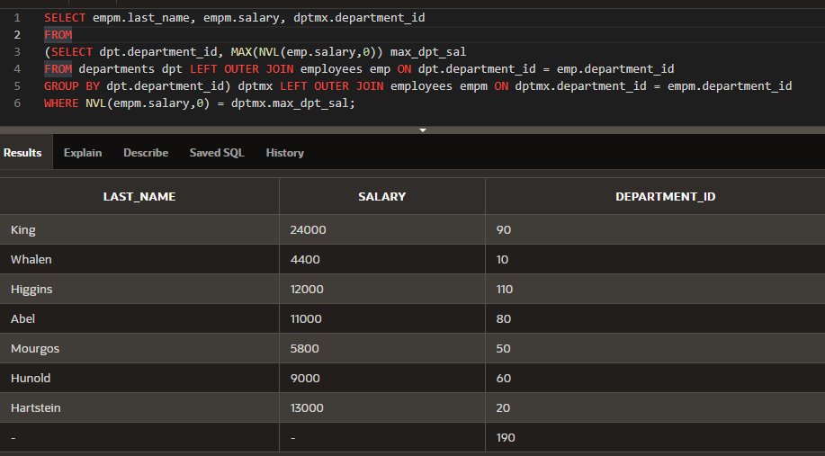

1. Create a query that will return the staff members of Global Fast Foods ranked by salary from lowest to highest.

SELECT ROWNUM,last_name, salary

FROM

(SELECT * FROM f_staffs ORDER BY SALARY);

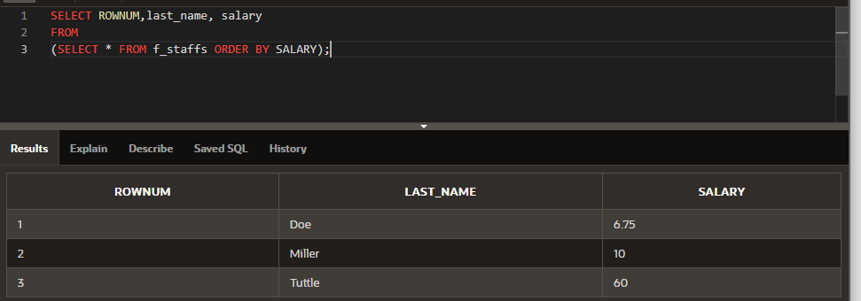

Extension Exercises

1. Create a new table called my_departments and add all columns and all rows to it using a subquery from the Oracle departments table. Do a SELECT * from my_departments to confirm that you have all the columns and rows.

CREATE TABLE my_departments

AS ( SELECT * FROM departments);

DESCRIBE my_departments;

DESCRIBE departments;

SELECT * FROM departments;

SELECT * FROM my_departments;

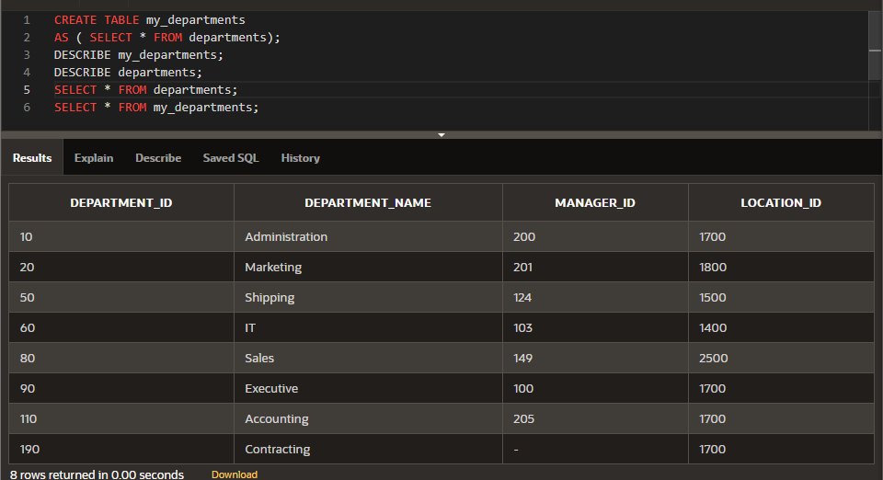

1. To view any constraints that may affect the my_departments table, DESCRIBE my_departments to check if any constraints were carried over from the departments table. If there are constraints on my_departments, use an ALTER TABLE command to DISABLE all constraints on my_departments.

DESCRIBE my_departments;

SELECT * FROM user_constraints WHERE table_name = UPPER('my_departments');

ALTER TABLE my_departments

DROP CONSTRAINT SYS_C00761279;

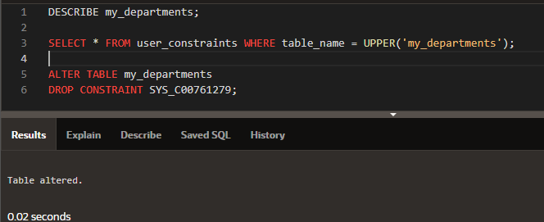

1. Create a view called view_my_departments that includes: department_id and department_name.

CREATE OR REPLACE VIEW view_my_departments AS

SELECT department_id , department_name

FROM my_departments;

SELECT * FROM view_my_departments ;

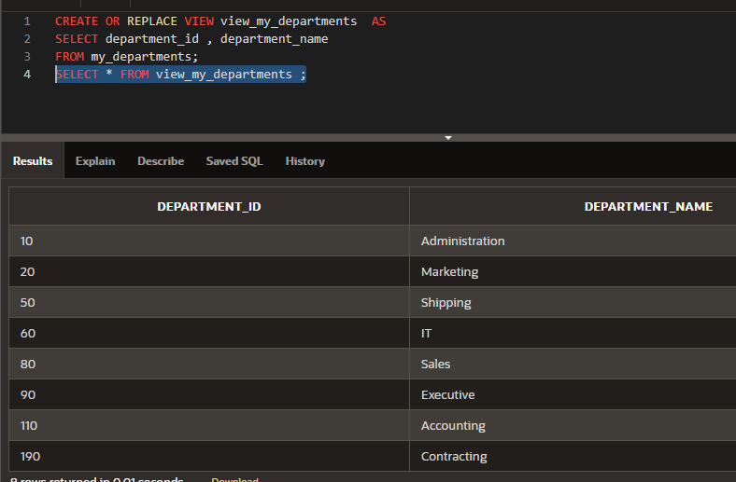

1. Add the following data to the my_departments table using view_my_departments.

|  |  |
| --- | --- |
| department_id | department_name |
| 105 | Advertising |
| 120 | Custodial |
| 130 | Planning |

INSERT INTO view_my_departments ( department_id, department_name)

VALUES(105, 'Advertising');

INSERT INTO view_my_departments ( department_id, department_name)

VALUES(120, 'Custodial');

INSERT INTO view_my_departments ( department_id, department_name)

VALUES(130, 'Planning');

SELECT * FROM my_departments;

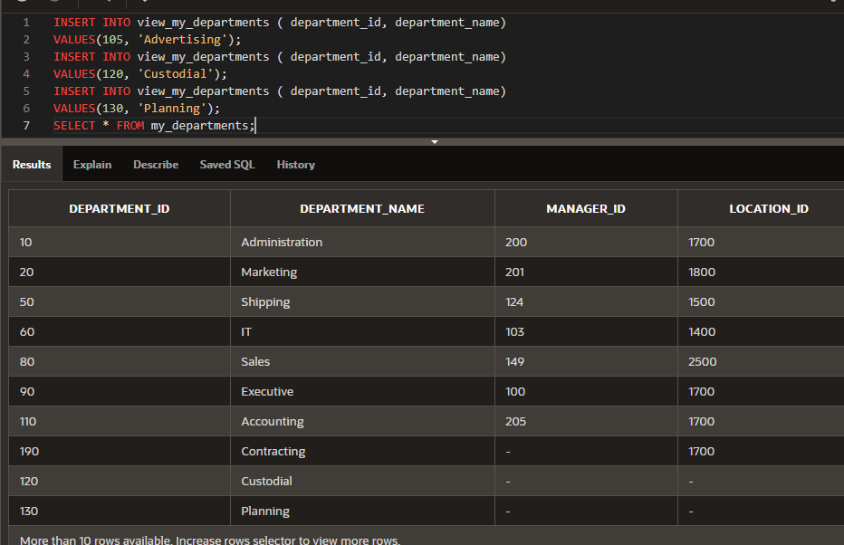

1. Create or enable the department_id column as the primary key.

ALTER TABLE my_departments

ADD CONSTRAINT my_departments_id_pk PRIMARY KEY (department_id);

DESCRIBE my_departments;

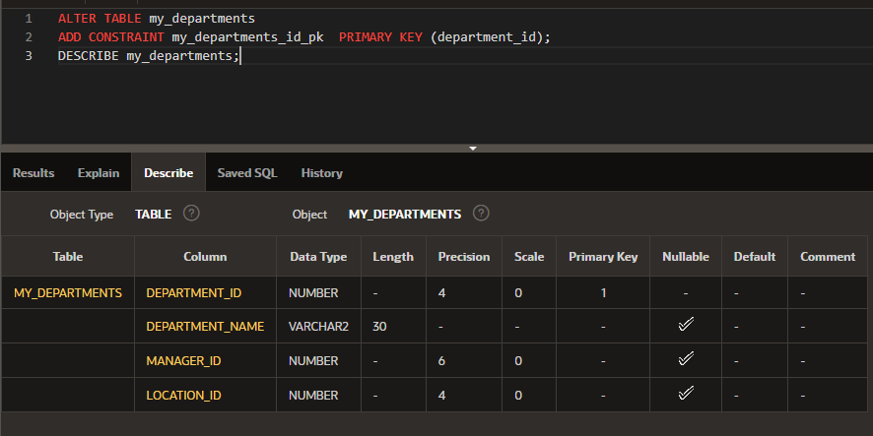

1. Enter a new department named Human Resources into the my_departments table using view_my_departments. Do not add a new department ID.

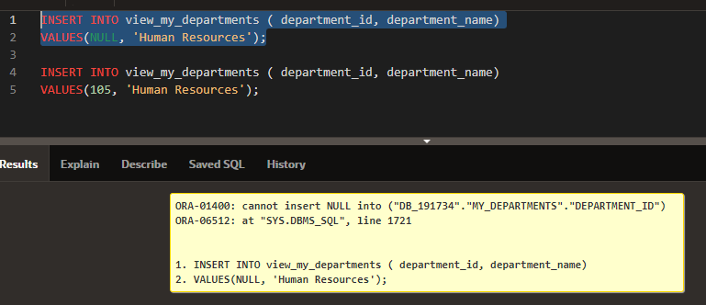

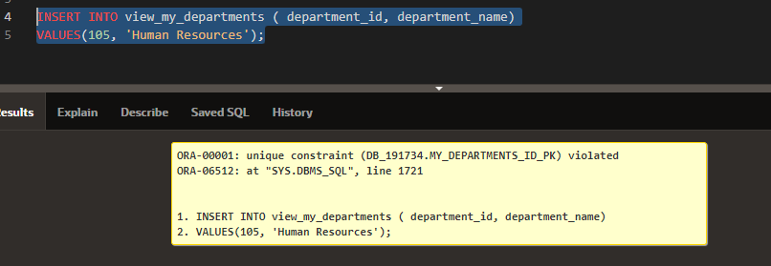

INSERT INTO view_my_departments ( department_id, department_name)

VALUES(NULL, 'Human Resources');

INSERT INTO view_my_departments ( department_id, department_name)

VALUES(105, 'Human Resources');

1. Add the Human Resources department, department ID 220, to my_departments using view_my_departments.

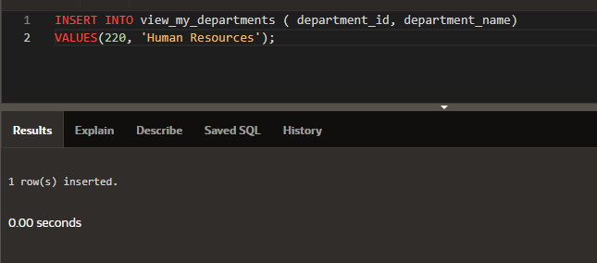

INSERT INTO view_my_departments ( department_id, department_name)

VALUES(220, 'Human Resources');

1. Verify that the new additions to my_departments were added using view_my_departments.

See chart below

SELECT * FROM my_departments;

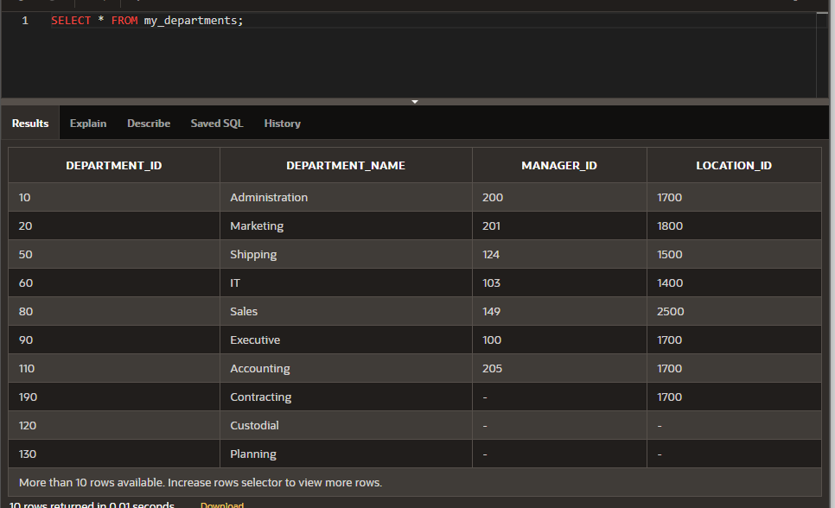

1. Modify view_my_departments to include location ID. Do a SELECT * command to show what columns are present and a DESCRIBE command to view the columns and associated constraints.

CREATE OR REPLACE VIEW view_my_departments AS

SELECT department_id , department_name, location_id

FROM my_departments;

SELECT * FROM view_my_departments ;

SELECT department_id , department_name, location_id

FROM my_departments;

DESCRIBE view_my_departments;

DESCRIBE my_departments;

SELECT * FROM user_constraints WHERE table_name = UPPER('view_my_departments');

SELECT * FROM user_constraints WHERE table_name = UPPER('my_departments');

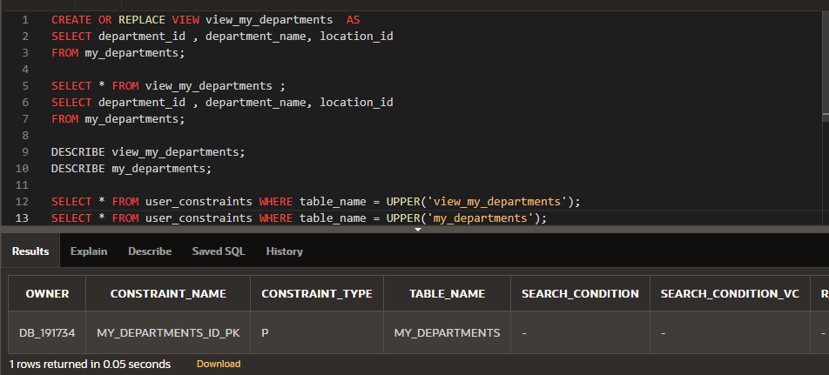

1. Make location_id a NOT NULL column in the my_departments table.

UPDATE my_departments

SET location_id = 1800

WHERE location_id IS NULL;

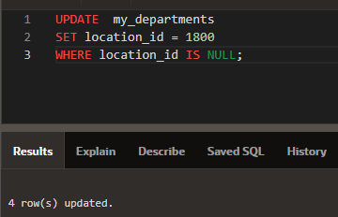

ALTER TABLE my_departments

MODIFY ( location_id NUMBER(4,0) CONSTRAINT my_departments_loc_id_nn NOT NULL);

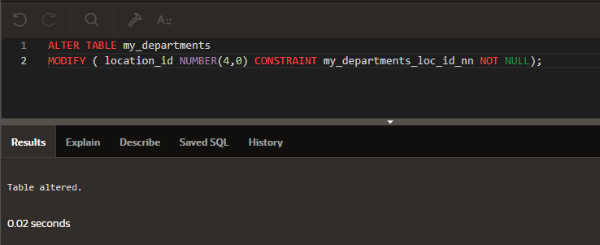

DESCRIBE my_departments;

SELECT * FROM user_constraints WHERE table_name = UPPER('my_departments') AND constraint_type = 'C';

ALTER TABLE my_departments

DROP CONSTRAINT MY_DEPARTMENTS_LOC_ID_NN;

SELECT column_name, nullable FROM user_tab_columns

WHERE table_name = UPPER('my_departments');

1. Using the Oracle database, create a complex view between locations and departments with only the following columns: department_name, street_address, city, and state. Include only U.S. cities. Verify that the view was created using a SELECT * statement.

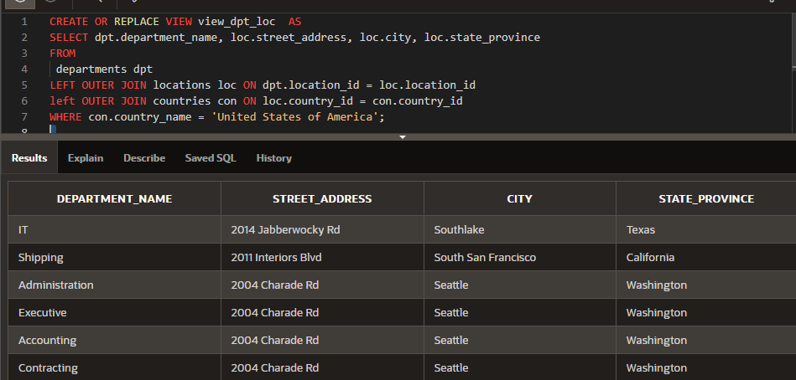

CREATE OR REPLACE VIEW view_dpt_loc AS

SELECT dpt.department_name, loc.street_address, loc.city, loc.state_province

FROM

departments dpt

LEFT OUTER JOIN locations loc ON dpt.location_id = loc.location_id

left OUTER JOIN countries con ON loc.country_id = con.country_id

WHERE con.country_name = 'United States of America';

SELECT * FROM view_dpt_loc;

See chart below

Results of select statement from view:

